
Qwwdq

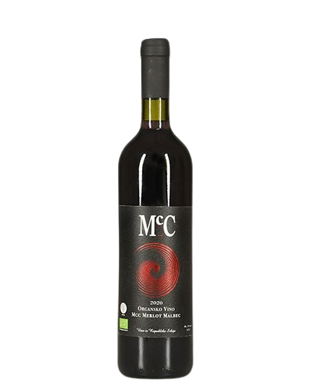
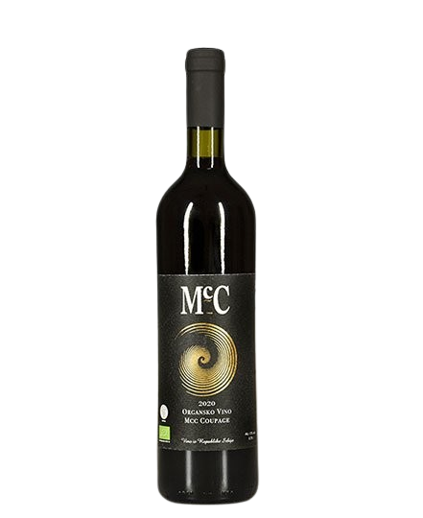
Merlot-Malbec
- Dry red wine -

About the vine

Grape variety:
- Merlot
- Malbec
Origin: Erdevik, Fruška Gora
Serving temperature:13-15 ºC

A blend of two grape varieties with a dominant influence of Merlot. The blend consists of 70% Merlot and 30% Malbec.
It displays a pronounced fruity character (plum, cherry) with floral and spicy notes. Through aging, the wine develops aromas of sweet oak and vanilla. It is aged for 18 months in oak barrels and then at least an additional 10 months in bottle.
Food pairing includes beef salad, stuffed fried peppers, pork knuckle with horseradish, grilled dishes, steak, semi-hard cheeses, and lasagna.
We use the Bordeaux technique of co-fermenting grapes. Merlot and Malbec are fermented together so they can ripen in harmony, as they are harvested at the same time.
Primary fermentation takes place in stainless steel tanks. Near the end of fermentation, the wine is transferred into oak barrels using a Spanish technique inspired by Ribera del Duero, which creates a distinctive creamy texture. Controlled oxygen exposure through the barrel supports aging and development. After fermentation, the wine is removed, the barrels are cleaned with ozone, and then refilled. The wine is aged for at least 12 months in barrel, followed by at least 10 months in bottle.
Malbec is a grape variety first planted in Serbia by Don McCulloch. Originally from the Médoc region, it is successfully cultivated on Fruška Gora due to its favorable climate and sufficient sunlight.
We produce an average of around 3,000 bottles of Merlot–Malbec per year.

Awards

2024 – The 2020 vintage won a bronze medal at the Wine Vision by Open Balkan.
2023 – The 2018 Merlot–Malbec won a silver medal at the Wine Vision by Open Balkan.
2022 – The 2017 Merlot–Malbec won a silver medal at the Wine Vision by Open Balkan.
2021 – The 2017 vintage won a gold medal at the Rivica Wine & Food Festival.
2015 – The 2012 vintage was recognized at the Decanter World Wine Awards.
2015 – The 2012 vintage won a gold medal in Croatia at the Gastro Fest.

